**DIGITAL MARKETING ASSIGNMENT**

1.Create a blog or website using Blogspot and WordPress. Customize the theme design and post new article with 500 words.

SCREENSHOT:

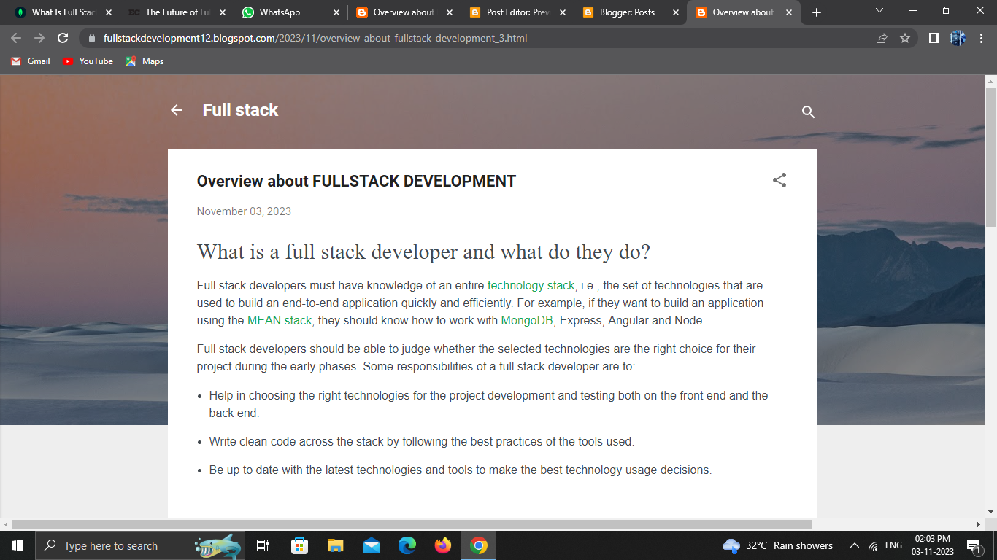

LINK[: https://fullstackdevelopment12.blogspot.com/2023/11/overview-about-fullstack-development_3.html  
|](https://fullstackdevelopment12.blogspot.com/2023/11/overview-about-fullstack-development_3.html)2. . Create a New Facebook Business Page and post one social media poster for your brand.

SCREENSHOT:

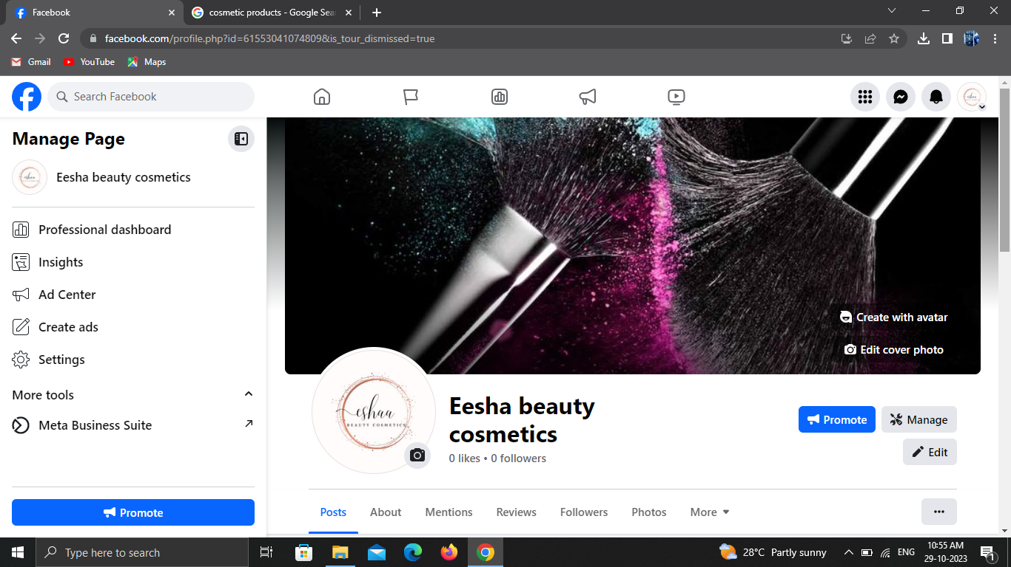

PROFILE LINK:

<https://www.facebook.com/profile.php?id=61553041074809&mibextid=ZbWKwL>

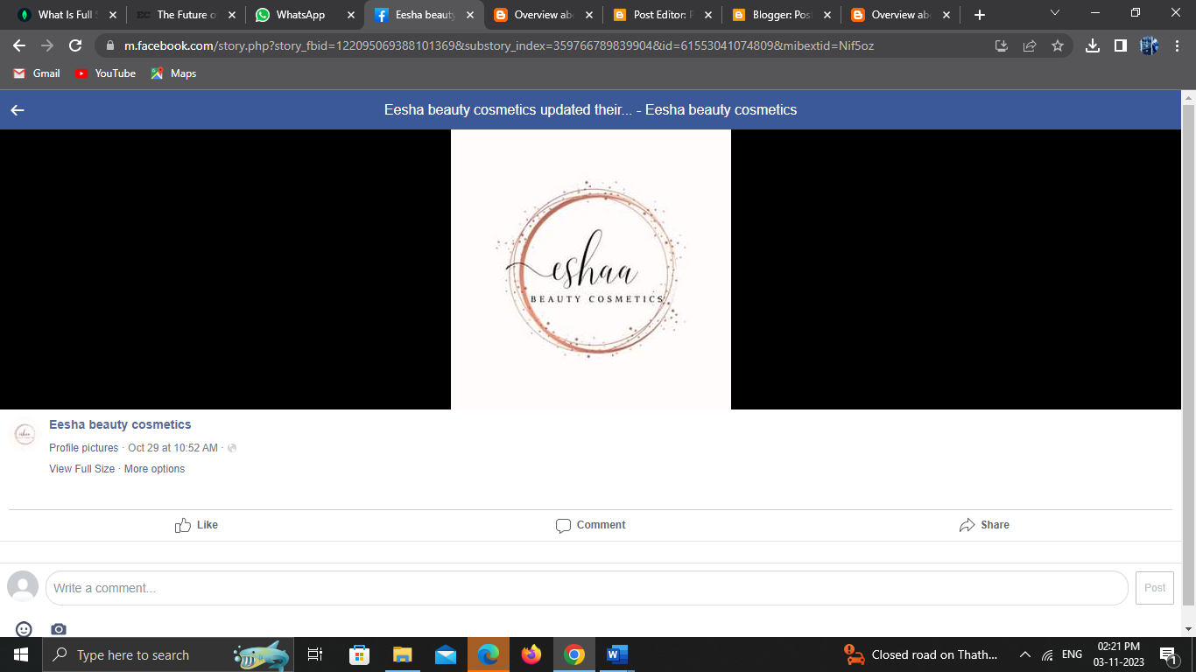

POST LINK:  
**<https://m.facebook.com/story.php?story_fbid=122095069388101369&substory_index=359766789839904&id=61553041074809&mibextid=Nif5oz>**

3. Create and design a social media advertisement poster using canva.



LINK:

<https://www.canva.com/design/DAFynSn08ow/opGqqUALdMHIZC2yNfyyfA/edit?utm_content=DAFynSn08ow&utm_campaign=designshare&utm_medium=link2&utm_source=sharebutton>

4. Create email newsletter design using MailChimp or canva tool.



LINK:

<https://www.canva.com/design/DAFynvDFtl8/vdenwEa0wwBQlRW56H1bNQ/edit?utm_content=DAFynvDFtl8&utm_campaign=designshare&utm_medium=link2&utm_source=sharebutton>